**Practical-4**

**Aim: Draw the structural view diagram: E-R Diagram.**

**4.1 E-R Diagram:**

**4.1.1 Introduction:**

Entity-Relationship model is used to represent a logical design of a database to be created. In ER model, real world objects (or concepts) are abstracted as entities, and different possible associations among them are modeled as relationships. We represents the attributes, entities and relation using the ER diagram. Using this ER diagram, table structures are created, along with required constraints. Finally, these tables are normalized in order to remove redundancy and maintain data integrity. Thus, to have data stored efficiently, the ER diagram is to be drawn as much detailed and accurate as possible.

**4.1.2 Symbols used in E-R diagram:**

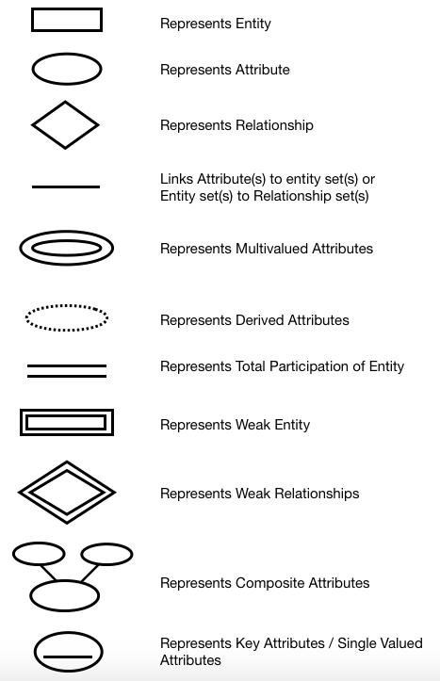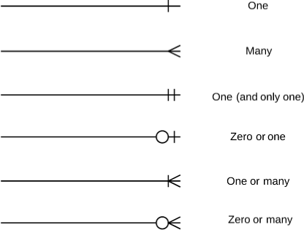

**4.1.3 E-R diagram for Propre Cuisine System:**

